# Version History

| **Version** | **Date** | **Additions / Modifications** | **Prepared / Revised By** |
| --- | --- | --- | --- |
| 1.0 | 25-08-2023 | Initial version | Shiena Clare Parac |
|  |  |  |  |
|  |  |  |  |

## Interface / API Design

## https://dev.azure.com/dd-managed-services/PE%20-%20Mule%20Enablement%20APAC/_git/shienaclare-parac-api-weather-v1?path=/src/main/resources/api/api-weather-v1.raml

## Operation description

GET /api/users – Create users

## Sequence Diagram

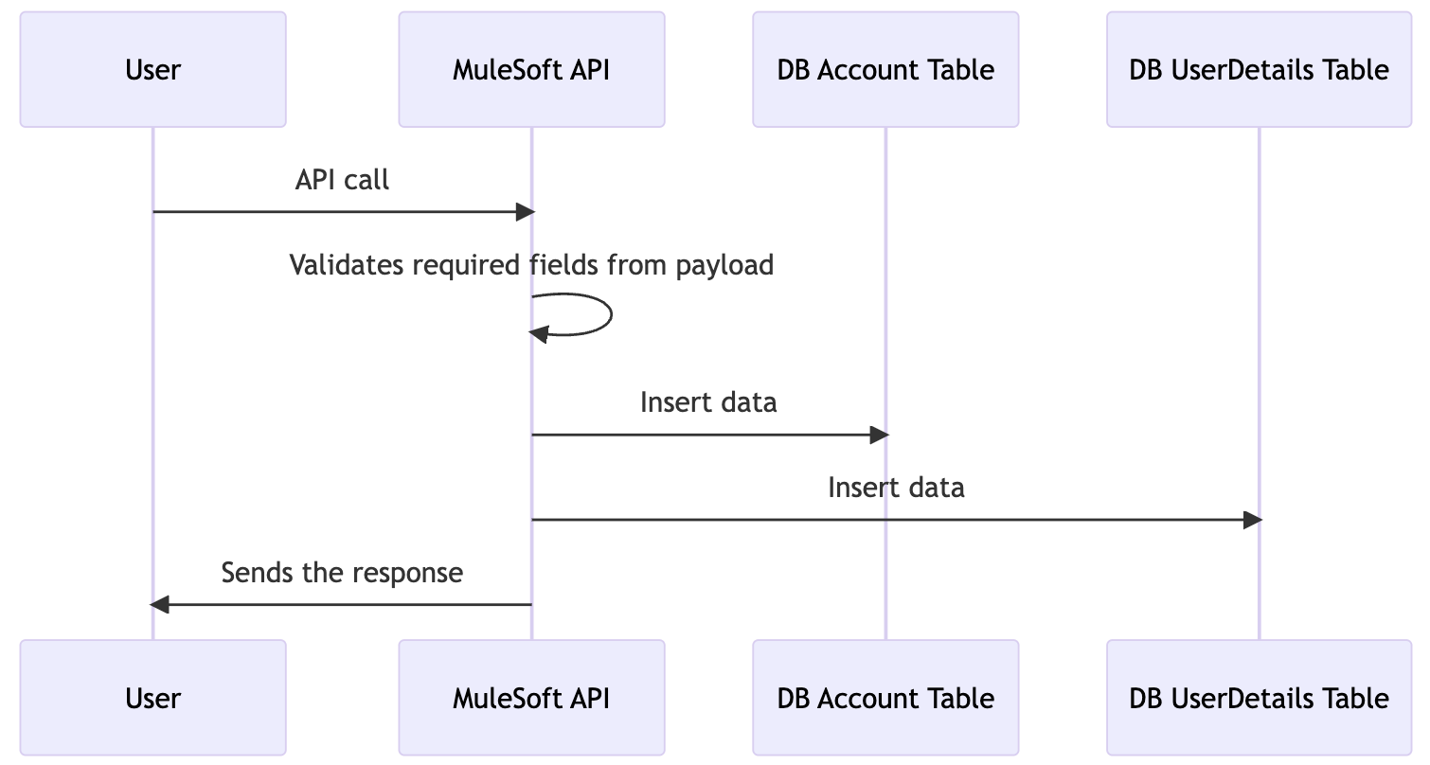

## Data Mapping and Transformation Rules (API - end point)

### **/users Request - Header**

| **Param** | **Param Type** | **Value** |
| --- | --- | --- |
| requestCode | Header | aOEF3M2cEG0204NO |

### **/users** **Request payload**

|  |
| --- |
| {  "users": [{  "username": "john123",  "fullname": "John White Smith",  "birthday": "02-05-1990",  "gender": "male",  "dateRegistered": "20-08-2012"  },  {  "username": "jackpeters",  "fullname": "Jack Peters",  "birthday": "11-06-1985",  "gender": "male",  "dateRegistered": "25-09-2014"  },  {  "username": "jenniesummers",  "fullname": "Jennie Summers",  "birthday": "12-11-1979",  "gender": "female",  "dateRegistered": "20-08-2013"  }  ]  } |

### **/users** **Response payload**

#### **/cities** **Response (Success)**

|  |
| --- |
| [  {  "country": "Australia",  "cities": [  "Archerfield Aerodrome",  "Amberley Aerodrome",  "Alice Springs Aerodrome",  "Brisbane Airport M. O",  "Coolangatta Airport Aws",  "Cairns Airport",  "Charleville Airport",  "Gladstone",  "Longreach Airport",  "Mount Isa Amo",  "Mackay Mo",  "Oakey Aerodrome",  "Proserpine Airport",  "Rockhampton Airport",  "Broome Airport",  "Townsville Amo",  "Weipa City",  "Gove Airport",  "Tennant Creek Airport",  "Yulara Aws",  "Albury Airport",  "Devonport East",  "Goldstream Aws",  "East Sale Aerodrome",  "Hobart Airport",  "Launceston Airport",  "Laverton Aerodrome",  "Moorabbin Airport Aws",  "Mount Gambier Aerodrome",  "Mildura Airport",  "Melbourne Airport",  "Macquarie Island",  "Wynyard West",  "Adelaide Airport",  "Albany Airport",  "Broken Hill Patton Street",  "Ceduna Airport",  "Derby",  "Darwin Airport",  "Bullsbrook Pearce Amo",  "Edinburgh M. O.",  "Forrest Airport",  "Geraldton Airport",  "Kalgoorlie Boulder Amo",  "Kununurra Kununurra Aws",  "Leigh Creek Airport",  "Learmonth Airport",  "Meekatharra Airport",  "Port Hedland Pardoo",  "Parafield Airport",  "Belmont Perth Airport",  "Katherine Aerodrome",  "Woomera Aerodrome",  "Bankstown Airport Aws",  "Canberra",  "Coffs Harbour Mo",  "Cooma",  "Camden Airport",  "Dubbo",  "Norfolk Island Airport",  "Nowra Ran Air Station",  "Richmond Aus-Afb",  "Sydney Airport",  "Tamworth Airport"  ]  },  {  "country": "Philippines",  "cities": [  "Taguig City",  "Cebu City"  ]  }  ] |

#### **/cities Response (Error)**

|  |
| --- |
| {  "error": {  "status": "500",  "code": "SERVER_ERROR",  "title": "Internal server error",  "details": "The server encountered an unexpected condition which prevented it from fulfilling the request"  }  } |

### Response Status Code and Headers

| **Key** | **Value** |
| --- | --- |
| Success | 200 |
| BAD_REQUEST | 400 |
| NOT_FOUND | 404 |
| METHOD_NOT_ALLOWED | 405 |
| NOT_ACCEPTABLE | 406 |
| MEDIA_TYPE_UNSUPPORTED | 415 |
| SERVER_ERROR | 500 |
| NOT_IMPLEMENTED | 501 |
| TIMEOUT | 504 |
| **Description** | **Code** |
| Success | 200 |
| BAD_REQUEST | 400 |

Source to Target Message Mapping (Request / Response)

| **Source Service Name** | **Source Field Name** | **DataType** | **Sample** | **Target Service** | **Target Service Field Name** | **Sample** | **Optional** | **Transformation Rules / Business Rules** | **Notes** |
| --- | --- | --- | --- | --- | --- | --- | --- | --- | --- |
| GET /cities |  |  |  | /GlobalWeather |  |  |  | N/A |  |
|  | country |  |  |  | countryName |  | **Y** |  |  |

## Operation description

GET /api/weather – Get weather

## Sequence Diagram

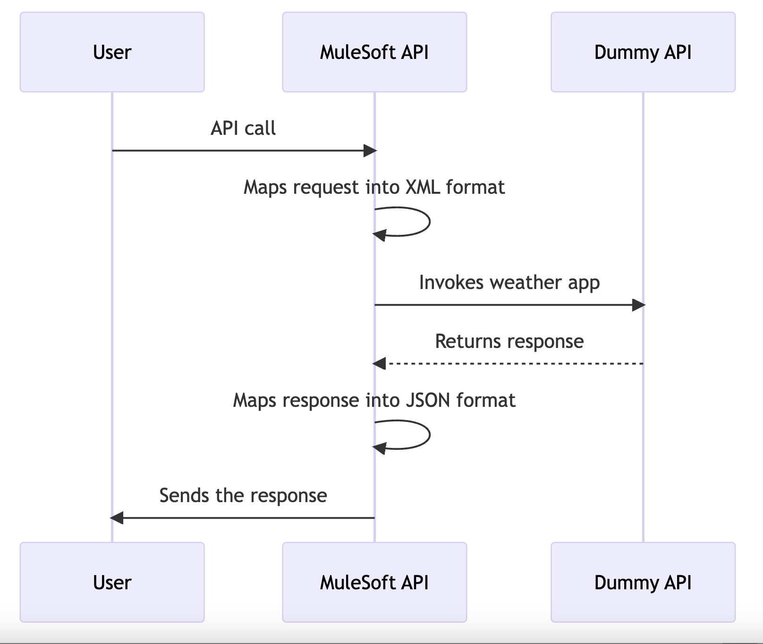

## Data Mapping and Transformation Rules (API - end point)

### **/weather Request - Header**

| **Param** | **Param Type** | **Value** |
| --- | --- | --- |
| country | Query Parameter | Ex. “Australia” |
| city | Query Parameter | Ex. “Melbourne” |

### **/weather** **Response payload**

#### **/cities** **Response (Success)**

|  |
| --- |
| [  {  "country": "Australia",  "weatherDetails": [  {  "country": "Australia",  "location": "Melbourne",  "time": "11 AM",  "wind": "15 km per hour",  "visibility": "10 km",  "skyConditions": "sunny",  "temperature": 18,  "dewPoint": "2 C",  "relativeHumidity": 35,  "status": "Normal"  },  {  "country": "Australia",  "location": "Amberley Aerodrome",  "time": "12 AM",  "wind": "16 km per hour",  "visibility": "11 km",  "skyConditions": "sunny",  "temperature": 18,  "dewPoint": "3 C",  "relativeHumidity": 36,  "status": "Normal"  }  ]  },  {  "country": "Philippines",  "weatherDetails": [  {  "country": "Philippines",  "location": "Cebu City",  "time": "9 AM",  "wind": "20 km per hour",  "visibility": "15 km",  "skyConditions": "rainy",  "temperature": 20,  "dewPoint": "2 C",  "relativeHumidity": 40,  "status": "Normal"  },  {  "country": "Philippines",  "location": "Taguig City",  "time": "10 AM",  "wind": "21 km per hour",  "visibility": "16 km",  "skyConditions": "rainy",  "temperature": 21,  "dewPoint": "3 C",  "relativeHumidity": 41,  "status": "Normal"  }  ]  }  ] |

#### **/weather Response (Error)**

|  |
| --- |
| {  "error": {  "status": "500",  "code": "SERVER_ERROR",  "title": "Internal server error",  "details": "The server encountered an unexpected condition which prevented it from fulfilling the request"  }  } |

### Response Status Code and Headers

| **Key** | **Value** |
| --- | --- |
| Success | 200 |
| BAD_REQUEST | 400 |
| NOT_FOUND | 404 |
| METHOD_NOT_ALLOWED | 405 |
| NOT_ACCEPTABLE | 406 |
| MEDIA_TYPE_UNSUPPORTED | 415 |
| SERVER_ERROR | 500 |
| NOT_IMPLEMENTED | 501 |
| TIMEOUT | 504 |
| **Description** | **Code** |
| Success | 200 |
| BAD_REQUEST | 400 |

Source to Target Message Mapping (Request / Response)

| **Source Service Name** | **Source Field Name** | **DataType** | **Sample** | **Target Service** | **Target Service Field Name** | **Sample** | **Optional** | **Transformation Rules / Business Rules** | **Notes** |
| --- | --- | --- | --- | --- | --- | --- | --- | --- | --- |
| GET /weather |  |  |  | /GlobalWeather |  |  |  | N/A |  |
|  | country |  |  |  | countryName |  | **Y** |  |  |
|  | city |  |  |  | CityName |  | **Y** |  |  |